# Requirements

Below is the set of requirements as delivered in assignment 1. Some additions have been made according to the feedback received.

**Use Case 1**

**Summary:** A doctor has an appointment, and will make a change to the global database.

**Actors:** Doctor, patient

**Precondition:** Patient has scheduled an appointment with the doctor

**Description:**

1. Doctor opens the patient’s EMR and views his medical history.
2. Patient comes into the doctor’s office at the appointed time.
3. Patient explains his problem to the doctor.
4. Doctor writes a summary and diagnosis on his tablet.
5. After the patient leaves, the doctor uploads this text to the EMR of the patient, so the global database is updated.

**Postcondition:** The database is updated with new information about the patient.

**Alternate flow:**

5a. The doctor edits an existing entry in the patient’s EMR.

**Use Case 2**

**Summary:** A patient schedules an appointment

**Actors:** Patient, appointment scheduling system, receptionist

**Precondition:** Patient is a user in the hospital system

**Description:**

1. Patient opens the hospital app on his phone.
2. Patient logs in on the app with his personal account.
3. Patient navigates to the part of the app for scheduling appointments.
4. Patient selects a time slot to schedule his appointment. (Exception: this time slot is already reserved)
5. The appointment scheduling system sends the request to a receptionist.
6. A receptionist approves the request.
7. The appointment scheduling system sends the appointment to the doctor.
8. The appointment is created in the global database.

**Exceptions:**

Time slot is already reserved. Raised when another patient reserves a time slot while this patient is in the process. Can be prevented by not allowing two patients to select the same time slot.

**Postcondition:** There is an appointment scheduled

**Use Case 3**

**Summary:** A nurse uses a mobile device, the recorded data is uploaded to the database.

**Actors:** Nurse, mobile device

**Precondition:** Patient is checked in to the hospital and has to have his blood pressure measured.

**Description:**

1. The nurse brings the mobile device to the patient
2. The nurse indicates on the mobile device which patient will be measured.
3. The nurse measures the blood pressure of the patient with the mobile device.
4. The mobile device automatically uploads this information to the global database, where it is included in the correct patient’s EMR.

**Postcondition:** The patient’s blood pressure is measured and the values are added to his EMR.

**Use Case 4**

**Summary:** An analyst reviews the data collected by the system

**Actors:** Analyst, central database

**Preconditions:** Analyst has access to the system, there has been data collected

**Description:**

1. Analyst logs in to the system with his personal account.
2. Analyst requests data from the central database.
3. Central database sends data to analyst.
4. Analyst performs his analysis on this data.

**Postcondition:** Data has been collected and analyzed.

**Use Case 5**

**Summary:** A patient orders medicine at his pharmacy through the website.

**Actors:** Patient, pharmacist, prescription management system, doctor

**Precondition:** Patient is registered in the system

**Description:**

1. Patient navigates to the website on his computer.
2. Patient logs in using his personal account.
3. Patient goes to the pharmacy’s part of the website.
4. Patient finds the medicine he wants to order.
5. Patient orders the medicine at the pharmacy.
6. The order is uploaded to the prescription management system
7. The prescription management system notifies the pharmacist.
8. Pharmacist reviews the order.
9. Pharmacist readies the medicine for the patient and updates the status in the prescription management system.
10. Patient receives a notification that his order is ready.
11. Patient picks up his order at the pharmacy.

**Postcondition:** Patient has his medicine.

**Alternate flow:**

1a-5a. A doctor places an order for medicine for his/her patient.

**Use Case 6**

**Summary:** Admin adds a new doctor to the system.

**Actors:** Admin, doctor

**Precondition:** The hospital has employed a new doctor.

**Description:**

1. The hospital sends the information of the new doctor to the admin.
2. The admin creates a new account for this doctor.
3. The admin sets the privileges of the newly created account.
4. The account credentials are sent to the new doctor.
5. The doctor uses the received credentials to log in to the system.

**Postcondition:** The doctor can log in the system, and only access the information that is relevant to him.

**Use Case 7**

**Summary:** Patient changes his personal information in the central database.

**Actor:** Patient

**Precondition:** Patient is registered in the system.

**Description:**

1. Patient navigates to the website on his computer.
2. Patient logs in using his personal account.
3. Patient navigates to the personal information section.
4. Patient clicks the button to change his information.
5. Patient supplies new information and clicks save.
6. The new information is added to the central database by the system.
7. The central database applies the change to all relevant systems.

**Postcondition:** The patient’s personal information has been changed.

# UML class diagram

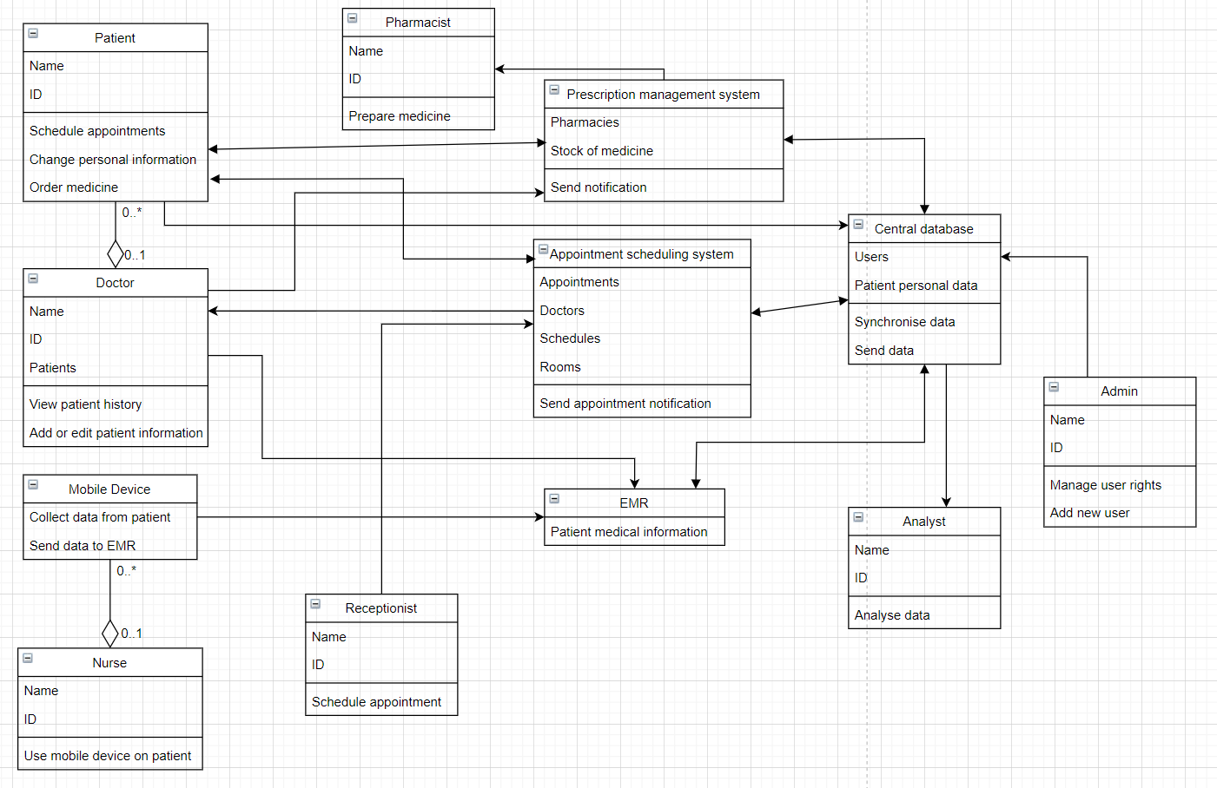

*Figure 1: An UML class model of a hospital management system.*